POWERTEACHER PRO KEY FEATURES
Ellie Schroeder eschroeder@esu10.org
Wayne Wiens wwiens@esu10.org
August 2020

- A+ Grading – Assignments: Assignment List
  - Change Term 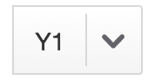
  - Select Course or Group
  - Filter
  - Sort columns by clicking on column titles
  - Green check mark in Scored column means all students have grades
  - Create Assignment
    - Select Classes
    - Score Type –
    - Due Date – can have different due dates for sections
    - Students Tab 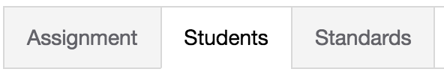
      - Can set assignment to specific kids 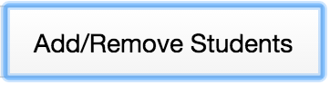
- A+ Grading – Assignments: Score Sheet
  - Shows only one course at a time
  - Sort assignments by date
  - Shows detailed information about the settings for the section
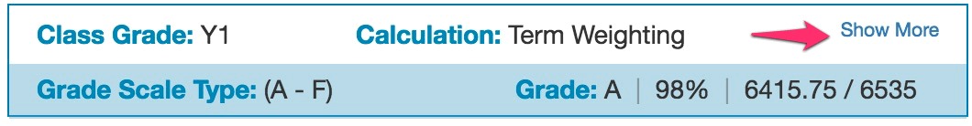
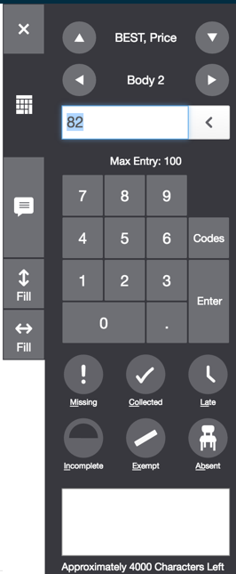
  - Score Inspector – displayed when a cell is selected
    - Keypad
    - Built in Indicators
      - Missing, Collected, Late, etc
    - Fill Down or Across
    - Fill Comments
    - Codes
      - Setup on the District side
        - EX: NHI, Cheat, etc
    - Navigate to next student or assignment
    - Can manually over-ride the final grade by clicking on it.

- A+ Grading – Assignments: Categories
  - Categories can be created on the Admin side & are shown by
  - Can show Inactive Categories
  - Edit Categories
    - Select Classes
    - Make Active
- A+ Grading – Grades: Traditional
  - New view: show attendance and assignment indicators
- A+ Grading – Grades: Comments
  - Shows comments for grading term
- A+ Grading – Grades: Category Total
  - Shows grade averages by category
- A+ Grading – Grades: All Reporting Terms
  - Shows grade averages by term
- Students - Assignments
- Students - Comment Log
- Students - Demographics
- Students - Assignments
- Students - Quick Lookup – Traditional
  - This is what student, parents & admins see
- Students - PowerTeacher Portal
  - Takes you to the start page of the PowerTeacher Portal. Same result as clicking the PowerSchool logo in the top left part of screen.
- Progress - Traditional
  - Graphically shows students by final grade range achieved
  - You can drill down by clicking
- Reports - Individual Student Report
  - Select different settings, such as print only students with D’s & F’s
  - Manually select specific students on the Students Tab
- Reports - Multi-Function Assignment Report
  - Shows scores for assignments based on criteria selected
- Reports - Setup -Student Roster
  - Prints students’ names with selected columns in spreadsheet form
- Settings – Setup -Class Descriptions
  - Can enter description for each class that parents can see.
- Settings – Setup -Display Settings
- Settings—Student Grade Scale
  - Can apply different grade scale to individual student
- Settings – Setup -Traditional Grade Calculations
  - This is where teachers setup the Final Grade Calculations
    - Admin can setup and lock the calculation and/or dropped scores
    - Be sure to do this for each course
- Functions – Recalculate Final Grades (icon at the top right)
  - Sometimes need to run when final grades are not calculating
- NEW: gradebook can be locked after grades are stored

