7-12 Band
Guidelines and Grading 2023-24
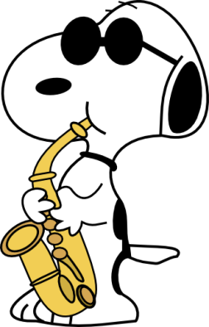
CLASS EXPECTATIONS
- ALWAYS GIVE YOUR BEST EFFORT.
- BE RESPECTFUL To the director, each other, and our school.
- Electronic devices will be stored in an approved area when entering class, (The Phone Zone) and can be picked up at the end of class.
- No Gum, Candy, or drinks in class (water is ok).

Not meeting the expectations will result in a loss of daily points, taking away a device, or detention if necessary.

GRADING
Breakdown Class Participation is 70%
Performances/Tests are 30%

- Class Participation 3 points per day will be given for productive, active, and consistent participation during class.

- Performances 20 points/ All performances are required and graded.

Missing a performance because of an illness or emergency will require make- up work.

Missing a performance because of work will result in a 0 and may not be made up.

Please let the director know at least 1 week ahead of time if you need to miss a performance.

*Students missing performances because of other school-sponsored activities are excused and will not be required to do make-up work.
CLASS ATTENDANCE & MAKE UP WORK
Band is a participation class, and rehearsal time is graded; therefore it is extremely important that students be in class.

Any absence from class will require make-up work. Practice time that students turn in will count toward make-up work.

Make-up work will be in the form of practice time or other music assignments approved by Mrs. Helgoth, and can be done during encore, at home, or before school.

Make up work should be done in an appropriate time frame as described in the student handbook.

INSTRUMENT RENTAL
Anyone using a school instrument (including percussion) must fill out a rental form and pay $25.00 per semester for the use of the instrument. The money is used for general repair and upkeep of school-owned instruments. (Valve oil and reeds are not included in the rental price.) Rental agreements need to be signed and returned at the beginning of the year.

SUPPLIES
Students are responsible for purchasing reeds, oil, grease, and other supplies needed for their instrument. Most of these may be purchased from the school. Checks should be made to: “BHS Music Activities.”

Performance Dates
First Semester Sept. 1 Home football game, play pep band
Sept. 8 Home football game, play pep band
Oct. 6 Home football game, play pep, Homecoming
Oct. 26 Fall Concert
Dec.14 Winter Concert

Second Semester March 27 Conference Music Contest @ St. Ed
April 11 Spring Concert
April 17 District Music Contest in Burwell

