Poems from:
Winter An Alphabet Acrostic
By Steven Schnur
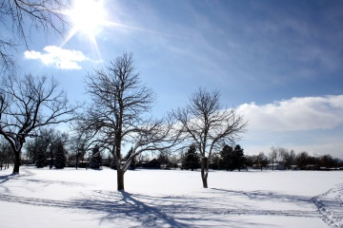

Other to make winter homes.
Great blocks of ice
On each
Lie Heaped
In the north country,

On front doors,
Lighted menorahs
Holly wreaths
Dinner guests, music
In living room windows,
Year’s end.
And gifts at

Narrow sticks to
Dad carries a
Inside – thick logs for heat,
Get the fire started.
Knee-deep
In
Load of wood
New snow,

Late for school
Into sweaters and boots,
Under warm covers
This cold, snowy morning.
Quickly we leap from

Rest in the
Light they drift
Rise like smoke before coming to
Upward
Yard.
Flakes so

