Poems from:
Autumn - An Alphabet Acrostic
By Steven Schnur
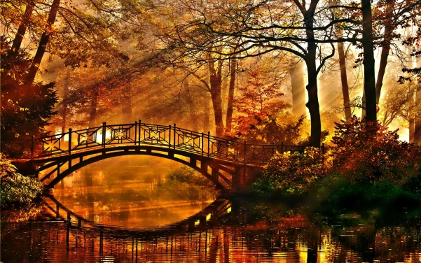
Rains down new
A single seed
Can feed a squirrel
Nuts every Autumn.
Or grow into a giant oak that

Vines have shriveled,
Aspen tree; even the grape
Season.
Each maple, oak, and
Ending another green
Little remains on

Nights turn frosty.
Come October,
Remain in the fields as the
Only the harvested stalks

Roost among empty
Bats
Nests.
And owls

Piled
In
November’s cold.
Kegs of cider, and an orange mountain
Up in the
Pears, bushels of apples,
Market square, baskets of

