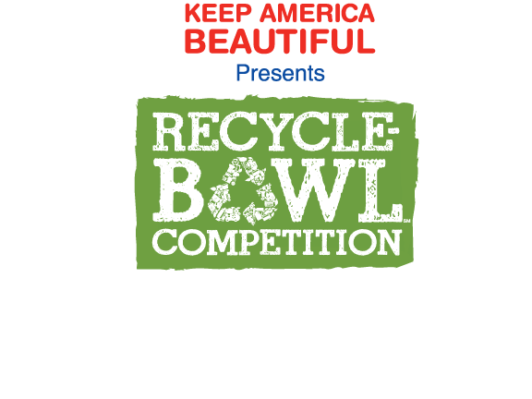
Burwell Elementary
Burwell, Nebraska
October 20, 2014-November, 14, 2014
In cooperation with
Keep Loup Basin Beautiful
an affiliate of
Keep America Beautiful

- Students at Burwell Elementary will be competing against other schools across the United States to see how many pounds of recyclables that they can collect.

- All recyclables will be weighed and charted.

- Students may bring recyclables every day of the week.

- Students will place the recyclables in the recycle bins that are clearly marked aluminum, plastic, and paper. The bins will be located at the West door.

- Trivia questions and information will be announced daily.

- Prizes will be given for correct answers to trivia.

- The recyclables will be collected and removed from the school building by Keep Loup Basin Beautiful.

Acceptable items to be recycled:
- Aluminum cans
- Paper—cereal boxes, newspapers, magazines, office paper, phone books
- Plastic bottles and containers

